Curriculum Vitae
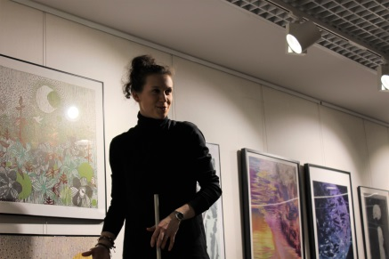
Marta Jóźwiak was born on August 18, 1995 in Gdansk.
Graduated Culture Animation at the interdepartmental institute of art (bachelor's degree) and artistic graphic (master degree) at the Academy of Fine Arts in Gdańsk.
Freelance illustrator and graphic designer.

Cooperations
- Grimpi clothing brand. Creating graphic design for t-shirts and pins.
- Chodź w góry (let’s go to the mountains). Creating series of graphics fo mugs.
- Vilnius lovers designing logo.
Creating logo and visual identifications propositions.

Exhibitions 2018/2019
- Organization and participation in the "here and now" exhibition in B90
- The second edition of the tram exhibition "precarious art"
- The first edition of the "24 H" exhibition at the WL4 gallery
- Young spring in the Refektarz gallery
- Nationwide exhibition of illustrations. “Mixtures of culture” in Wroclaw
- Individual exhibition at the Sopoteka Library
- Organization of the exhibition of analogue photography of Przemysława Koronkiewicza „People of 3city” in Sopoteka Library
- Organization of the exhibition for students from academy of fine students „Lino-lity” in Sopoteka Library
- Individual exhibition on Blokfit bouldering center in Gdansk
- Organization of the exhibition for students from academy of fine arts „Deja vu” in Sopoteka Library
- Taking part in „plastic not-fantastic” exhibition in Plama Gallery
- Taking part in „plastic not-fantastic” exhibition in Sea station on Hel peninsula

2017 r. – Conducting art workshops for seniors in Sopoteka
2015 r. – Conducting computer and art workshops for seniors in the 50 avenue foundation
- Cooperation in creating a mobile application "Shipyard is a woman"
- Cooperation in creating the project "old passions, new possibilities"
- Conducting art classes at the senior exhibition in Sopot
- Work on two editions of the event "Dj vs. jazzman "on Blokfit bouldering center
2012 r. – Taking second place in the Polish Championships in the odyssey of minds
2011 r. – Taking second place in the Polish Championships in the odyssey of minds
2010r. – Winning competition for the logo and poster design in the Exodus competition - all roads lead to Vilnius

Languages:
Polish – Native
English – fluent C1
German – A2
Computer programs
Affinity designer
Adobe photoshop
Illustrator
Microsoft Word
Contact: E-mail: jozwiakmarta95@gmail.com
Telephone number: +48664123012

